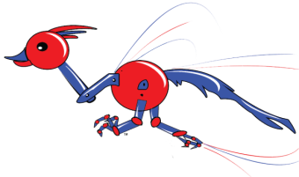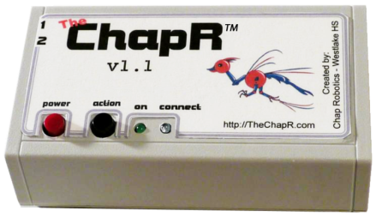

Come check us out at:

FRC 2468

FTC 3781

Westlake HS – Chap Robotics

ChapR

The

TM

Helping you cheat on your PC since 2013.

The Bluetooth remote control for:

* FTC Drive Practice
* FRC Demo Driving
* FLL Remote Control